ECE 465 Lab 10
Timing and Asynchronous Sequential Circuits
Summary
In the final lab, you will be reviewing timing analysis for circuits. Furthermore, you will also be learning about timing anaylsis in circuitverse and how it can be applied to the field.
Part 1. Timing in circuit verse
- In Circuitverse, you are able to read timing of wires through the timing diagram. This short tutorial will teach you how to use the timing diagram, while analyzing a basic ASC.
- Construct the following ASC:
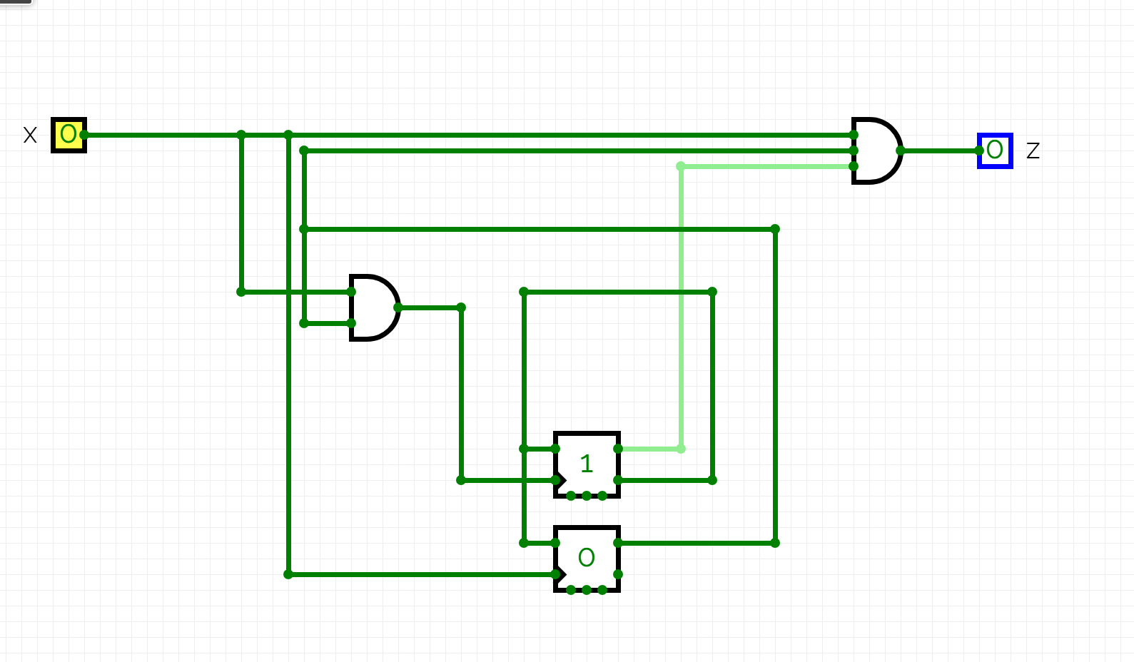
- Under circuit elements, locate misc, and then find the flag icon
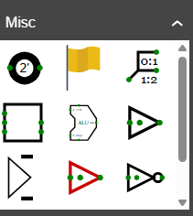
- Now attach the flags to the wires in the circuit
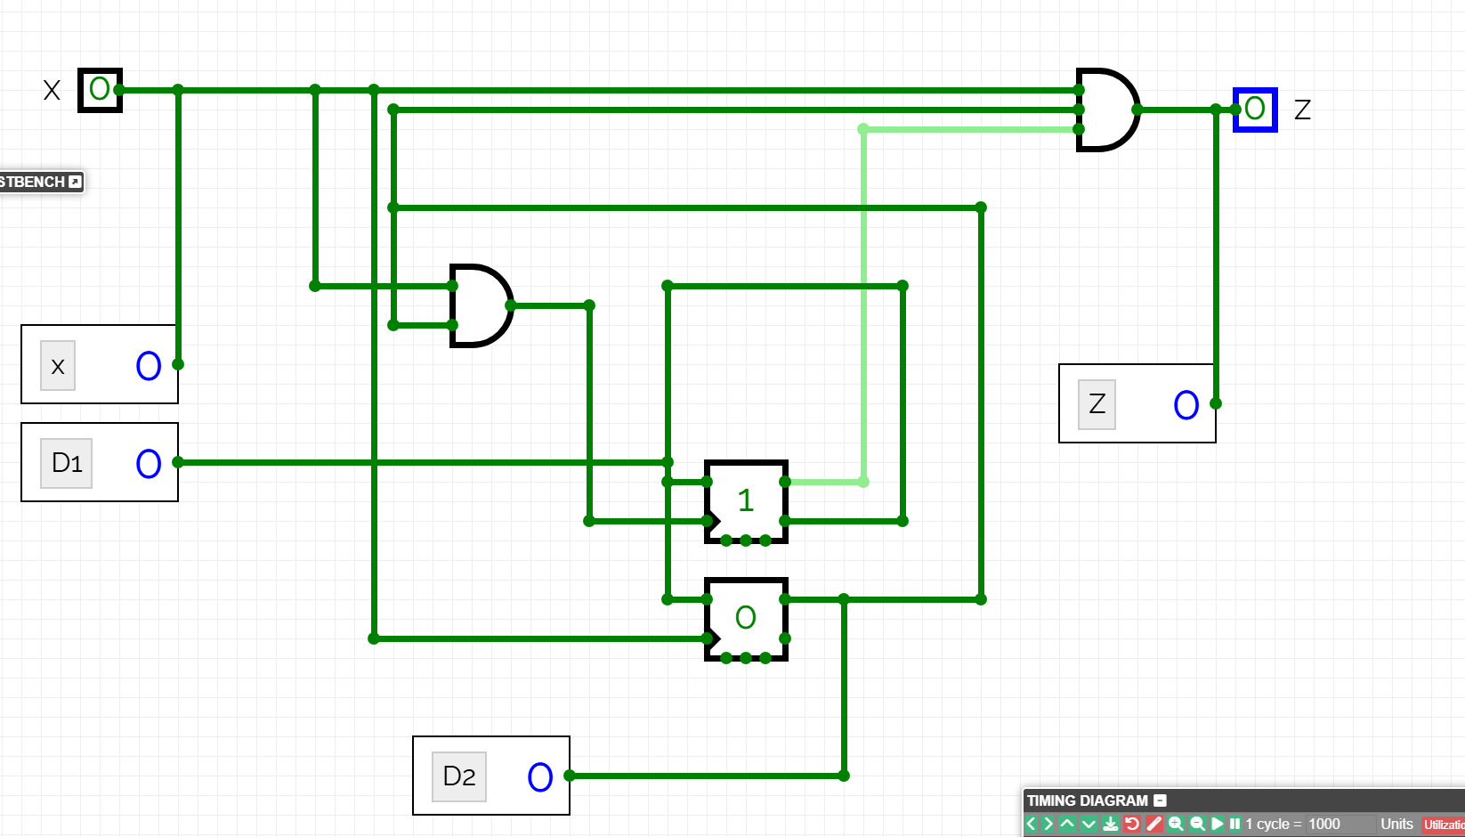
- Now open up the timing diagram
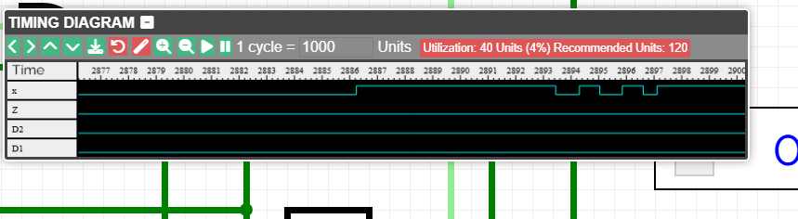
Here you can see the timing data for each variable place.

- Take a look at the following circuit. Create a timing diagram just like in the previous example.
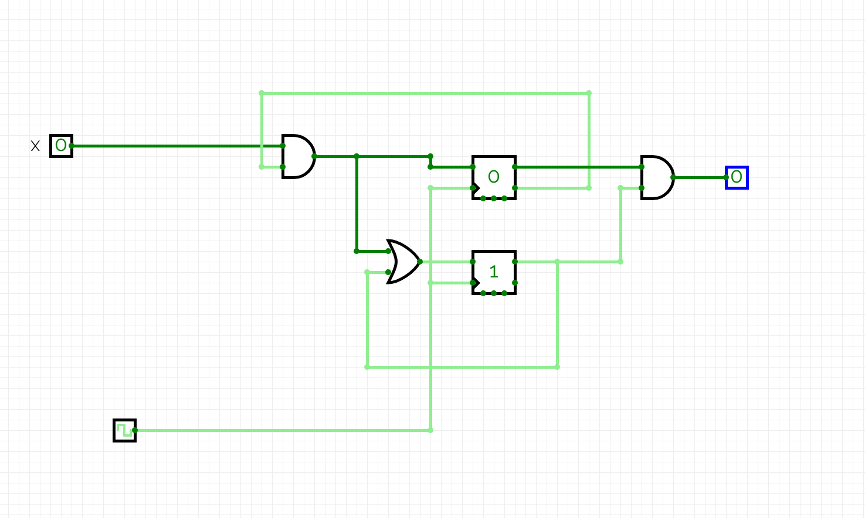

Part 2. Adding Delays to circuits
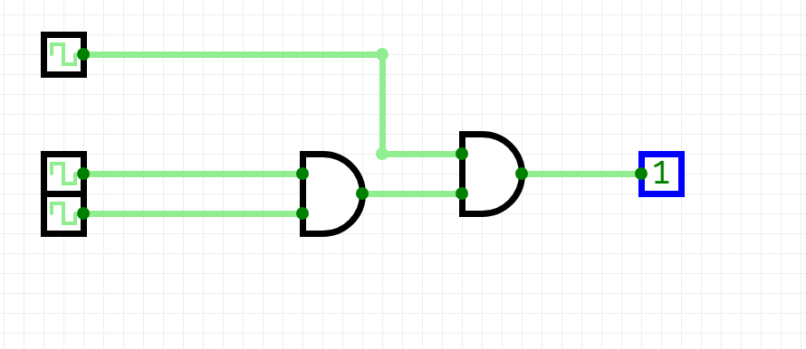
Under circuit properties, you can add a timing delay that will often result in a delay through the circuit. This can be used to add timing delays.

